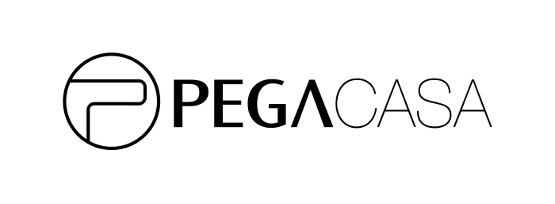
Return/Exchange Form
WHEREAS buyer to cancel the transaction or exchange demand, agreed to by the seller PEGA International Limited for return matters, so signing this Return Consent to active the exchanging/return process.
Contact Information：
Name |  | Member account( optional)
TEL
Email
Address
Order detail：
Order Number
Purchase Date
Product code and Q’ty | e.g:  F-002CX-BK-4.7  1pcs
Return Date
Reason
□ Return
□ Exchange

Please confirm the notice below in order to proceed the exchange/return process.
- Please complete the return/exchange form and send by FAX +8862 55637993 or email to pegacasa_service@pegatroncorp.com. Once we receipt the application, our customer service will arrange UPS carrier to pick up the package from you and please include this form with your return to the carrier.
Signature:____________________
Date：_________________________

